DocumentTitle

Distribution
KNS | Others | HT

0 | 11-Jul-08 | scyang | lmirambel | jgatawa | slawson | Completed
Rev. | Date  (dd/mmm/yyyy) | Author  (Name) | Checked  (Name) | Approved  (Name) | Approved  (Name) | Status
HT |  |  |  |  | Owner

Table of Contents
1. Introduction 1
2. Requirement 1
3. Modifications 2
3.1 Database 2
3.1.1 Tables 2
3.1.2 Stored Procedures 10
3.1.3 Triggers 12
3.1.4 User Defined Functions 13
3.2 PAF Reporting 14
3.2.1 PAF Report 14
3.2.2 PAF Report main menu (IIS) 24
4. Assumption and Constraint 25
5. Testing 26
5.1 PAF Adjustment 26
5.1.1 Test Cases: Access to PAF adjustment 26
5.1.2 Test Cases: Employee 27
5.1.3 Test Cases: PAF Timesheet Process 33
5.1.4 Test Cases: PAF Timesheet SAP Reconciliation 36
5.1.5 Test Cases: PAF Cost adjustment 36
5.1.6 Test Cases: PAF Function Invoice Edition 40
5.2 PAF Database 41
5.2.1 Test Cases: SQL Posting Timesheet to PAF 41

Introduction
The purpose of this report is to document the task and modification that had applied to PAF system for Koniambo Project. This includes the new design flow and system coding/ Interface. Besides, this report will document the testing result that we had encountered during the PAF testing stage and the solution to resolve the problem.

Requirement
During the meeting on 25 Feb’08, the new requirement and task are:-
    - Remove Workpackage relational, such as Group, Function, Discipline, Section, Area, SubArea, Unit and Workpackage table from PAF system. The purpose is to simplify the PAF system to be a basic Invoicing system.
    - Remove any related Human Resource function from PAF.
    - Remove any related Code adjustment function from PAF.
    - Create a job to transfer Koniambo timesheet from SQL eTimesheet into PAF.
    - Remove unnecessary report from PAF Report, keep only invoicing report.
    - Adding new field such as Email Address, for the Enotification usage.
    - Perform a PAF test based on the timesheet imported from SQL etimesheet.
    - Employee’s PayLocation and PayLocationRate will be entered by PAF Administrator later because of the information security purposes.
    - Re-check current PAF excel file data to rectify inconsistency. A report will be generated to assist the PAF Administrator to lookup for the inconsistency data, especially company employee number.

Kuala Lumpur
Technip Man-hours for Koniambo
SQL
PAF
Approved /Adjustment Timesheet
Timesheet

Technip/HTJV eTimesheet

Reporting

Figure 1: Brief Design Flow on eTRS and PAF

Furthermore, during the meeting on 27 Feb ’08, the new requirement and task are:-
      - Develop script to verify the total manhour in which charged to Koniambo under eCapture, SQL (Approved/ Rejected) and PAF (Timesheet + TimesheetErrors + DeleteTimesheet). The total amount of manhour should be matched.
e.g.: eCapture (1000) = SQL (500 + 500 = 1000) = PAF (250 + 250 + 0 = 500)
      - Explanation on double entry of Adjustment transaction from SQL eTimesheet.
      - The Job schedule to transfer Koniambo timesheet from SQL eTimesheet into PAF will be run once a week and starting on Sunday 03:00 a.m.

Extra Requirement
        - Consolidate Invoice for Oct, Nov and Dec’07. So that there will be appeared in Hours. However, the existing Hours appeared in those month will be removed from Timesheet table once the timesheet is pushed.
        - Besides, add new features in PAF Adjustment to compare the number of mismatch manhours in PAF and SAP and also the unexisted PAF staff with Koniambo manhours.

Modifications
The scope of modification includes
- Database: Tables, Store procedures, Functions and Triggers.
- PAF Adjustment: Code Adjustment, Cost Adjustment, Employee, Invoice Edition.
- Reporting: Extended Hour reporting and invoice reporting.

Database
The modification start by changing the tables, such as Workpackage, Group, Area, AuthorizedWorkpackage, EmployeeCategory, EmployeeProjectCategory, EmployeeType, FamilyStatus, Function, RelocationStatus, Section, SubArea and Unit. Those tables are removed since the tables are not in used in custom PAF system.

Tables

The major changes are to remove Workpackage from Database since the customized PAF system will be a simple invoicing system. Thus, there will not be any Cost Code and workpackage involved in the invoicing system according to the new requirement from the meeting on 25 Feb’08.

Removed tables:
        - ADGroupMembership
        - Area
        - AuthorizedWorkPackage
        - DBGroupMembership
        - EmployeeCategory
        - EmployeeProjectCategory
        - EmployeeType
        - FamilyStatus
        - Function
        - Group
        - PositionHistory
        - RelocationStatus
        - Section
        - SubArea
        - tblEmployeeListInvoicedPerLocation
        - tblEmployeeSignificantChanges
        - Unit
        - WBS
        - Workpackage

Besides, removed those unused tables from the database, unwanted field in the table is removed as well, for example Employee table (Initials, NoBilling, DesignatedProejctEmployee, EmployeeTypeID, EmployeeCategoryID, NDPTotalHoursApproved, NDPWorkApprovedForm, NDPWorkApprovedTo, projectSupervisor, RelaocationStatusID, FamilyStatusID, spuse, NumberOFChildern, RelaocationApproved, ClientApproved, RevisionDAte, PAFReceivedDate, DesignatedPostionID, ReportsTo, R&RHourlyRate, ActualDemobilisationDAte, TempID, EmployeeProjectCateroryID, OperatingCentreLocation, OvertimeClientApproved, OvertimeProjectApproved, OvertimePeriod, OvertimeWeeklyMax, WorkpackageID and Multiplier).

The fields are not using anymore since most of the related table is removed. Nevertheless, new fields are created such as email column in Employee table and PhaseID in Location table. Additional field is inserted in Location table since the report required the Phase description and deleting Workpackage will break the relation of Phase with other tables. Therefore, a new relation has to be established to link the Phase and Location.

Remaining tables are listed below

Table: Calendar
Column Name | Type | Description
ProjectWeekEndingDate | datetime | The week-end date of a given project week.
ProjectBillingMonth | datetime | The project billing month to which the week is assigned.
WeekOfYear | int | Incremental week number for the current year.
ProjectBillingYear | int | The project billing year to which the week is assigned.

Table: Company
Column Name | Type | Description
CompanyID | char | Three-letter company abbreviation.
CompanyName | varchar | Company full name.

Table: CostAdjustmentReasons
Column Name | Type | Description
ShortComment | varchar | Reference comment on Cost Adjustments.

Table: Currency
Column Name | Type | Description
CurrencyID | char | Three-letter country currency abbreviation
Description | char | Country currency description.
CurrencyTo ProjectRate | float | Ratio to USD
Comments | varchar | Remarks

Table: CurrencyHistory
Column Name | Type | Description
CurrencyID | char | Three-letter country currency abbreviation
Description | char | Country currency description.
CurrencyTo ProjectRate | float | Ratio to USD
Comments | varchar | Remarks
HistoryDate | Datetime | Date of creation
HistoryUser | Datetime | Creator

Table: DeletedTimesheet
Column Name | Type | Description
EntryID | int | Unique entry identifier.
CompanyID | char | Three-letter company abbreviation.
CompanyEmployeeNo | char | Specific company employee identification number.
EmployeeName | varchar | Employee name.
Hours | float | Employee working hours from current timesheet.
PostedDate | datetime | Timesheet processed date.
WeekEndDate | datetime | The week ending date of the week in which this set of hours was worked.
Hold | bit | Restrict employee Timesheet data from being processed.
AdjustingEntryID | int | Flags adjustment entries.
Loadedby | varchar | Person who loaded the data
LoadMode | Char | Loaded Mode
DeletedDate | Datetime | Deleting timesheet date
DeletedBy | Varchar | Person who deleted the data

Table: Discipline
Column Name | Type | Description
DisciplineID | int | Unique Discipline identifier.
DisciplineNo | char | Discipline Number set by Project.
Description | varchar | Unique Discipline description.
SortOrder | int | DisciplineID column sort hierarchy.

Table: Employee
Column Name | Type | Description
EmployeeID | int | Unique employee identifier
CompanyID | char | Three-letter company abbreviation.
CompanyEmployeeNo | char | Specific company employee identification number.
DisciplineID | int | Discipline identifier
LastName | varchar | Employee last name
FirstName | varchar | Employee first name
TotalHoursImported | float | Employee total worked hours (invoiced & non-invoiced).
CompanyLineManagerName | varchar | Company Unit manager
Email | Varchar | Email Address
Comments | varchar | Remarks
PAFNo | varchar | A file number referring to the documentation via which information about the employee’s assignment was submitted.
PAFRevisionNO | int | Revision number of the employee’s latest record.
StartDate | datetime | Employee project start date.
RatePayLocation | char | The individual’s pay (or home, or reporting) location.
RatePayCurrencyID | char | The currency in which the individual is paid.
EHAHourlyRate | decimal | The individual’s base hourly rate.
RateAssignLocation | char | Employee location for non-labour costs.
RateAssignCurrencyID | char | Employee non-labour currency
ActualDemobilisationDate | datetime | Actual employee finish date on project date.
Creator | varchar | Person who created the Employee record.
CreationDate | datetime | Date of creation.
EffectiveDate | datetime | PAF form effectiveness date.

Table: EmployeeHistory
Column Name | Type | Description
EmployeeID | int | Unique employee identifier
CompanyID | char | Three-letter company abbreviation.
CompanyEmployeeNo | char | Specific company employee identification number.
DisciplineID | int | Discipline identifier
LastName | varchar | Employee last name
FirstName | varchar | Employee first name
TotalHoursImported | float | Employee total worked hours (invoiced & non-invoiced).
CompanyLineManagerName | varchar | Company Unit manager
Email | Varchar | Email Address
Comments | varchar | Remarks
PAFNo | varchar | A file number referring to the documentation via which information about the employee’s assignment was submitted.
PAFRevisionNO | int | Revision number of the employee’s latest record.
StartDate | datetime | Employee project start date.
RatePayLocation | char | The individual’s pay (or home, or reporting) location.
RatePayCurrencyID | char | The currency in which the individual is paid.
EHAHourlyRate | decimal | The individual’s base hourly rate.
RateAssignLocation | char | Employee location for non-labour costs.
RateAssignCurrencyID | char | Employee non-labour currency
ActualDemobilisationDate | datetime | Actual employee finish date on project date.
Creator | varchar | Person who created the Employee record.
CreationDate | datetime | Date of creation.
EffectiveDate | datetime | PAF form effectiveness date.
HistoryDate | Datetime | History created date
HistoryUser | varchar | History creator

Table: ErrorDefinition
Column Name | Type | Description
ErrorID | char | Unique identifier.
ErrorMessage | varchar | Message description
Fatal | bit | Error code.

Table: Hours
Column Name | Type | Description
EntryID | int | Unique identifier inserted from Timesheet table
CompanyID | char | Three-letter company abbreviation
EmployeeID | int | Unique employee identifier
PostedDate | datetime | Latest ProjectWeekEndingDate from when timesheet loaded.
ProjectWeekEndingDate | datetime | Represents the week ending date of the week in which the hours were worked.
ParentCompanyPostedDate | datetime | Date from parent company when employee timesheet was processed.
Hours | decimal | Employee working hours from current timesheet.
RatePayLocation | char | Employee’s pay location.
RatePayCurrencyID | char | Employee’s pay currency.
RateSalBaseHourlyRate | decimal | Employee hourly base salary rate
RateAssignLocation | char | Employee location for non-labour costs.
RateAssignCurrencyID | char | Employee non-labour currency
Multiplier | float | Employee pay-rate adjuster
OtherOfficeSpaceRate | decimal | Employee non-labour area charge rate
OtherOfficeExpensesRate | decimal | Employee non-labour area charge rate
OtherITRate | decimal | Employee non-labour area charge rate
OtherITCoreRate | decimal | Employee non-labour area charge rate
OtherOfficeSpace | decimal | Employee non-labour area hours charged
OtherOfficeExpenses | decimal | Employee non-labour area hours charged
OtherIT | decimal | Employee non-labour area hours charged
OtherITCore | decimal | Employee non-labour area hours charged
LabourCost | decimal | Employee labour hours charged
LabourInvoiceNo | char | Refers to the invoice number in which the direct labour cost for this set of hours is included.
NonLabourInvoiceNo | char | Refers to the invoice number in which the non-labour reimbursable costs for this set of hours have been included.
Adjustment | char | Invoice cost adjustment
AdjustmentShortComment | varchar | Brief adjustment comment
AdjustmentLongComment | varchar | Detailed adjustment comment
AdjustmentDate | datetime | Adjustments date
AdjustmentUser | varchar | Adjustment by.
Loadedby | Varchar | Person who loaded the data.
LoadMode | char | Indicate load mode, such as Manual.

Table: HoursErrors
Column Name | Type | Description
EntryID | int | Unique identifier inserted from TimesheetErrors table
ErrorID | char | Description of error
ErrorDate | datetime | Date error occurred
Validated | bit | Has error been fixed?
ValidatedDate | datetime | Date error fixed.

Table: Invoices
Column Name | Type | Description
InvoiceNo | char | Unique invoice identifier
InvoicingDate | datetime | Date invoice created
ProjectBillingMonth | datetime | Invoice period (month).
CurrencyID | char | Three-letter country currency abbreviation
CurrencyToUSD | float | Country currency conversion to USD.
ProducedBy | varchar | Invoice generated by.
ProducedDate | datetime | Invoiced generated date.
Closed | Bit | Flag to indicate the invoice is closed.
ClosedBy | Varchar | Person who closed the invoice.
CloseDate | Datetime | Date of closing the invoice.

Table: Location
Column Name | Type | Description
LocationID | char | Three-letter country abbreviation.
LocationName | varchar | Country full length name.
CompanyID | char | Three-letter company abbreviation.
CurrencyID | char | Three-letter country currency abbreviation
StandardWorkingHours | int | Employee standard week working hours.
Multiplier | float | Applicable overhead multiplier for this location, according to contract conditions.
OtherOfficeSpace | decimal | Hourly rate for office space charge applicable for the location.
OtherOfficeExpenses | decimal | Hourly rate for general office expenses applicable for the location.
OtherIT | decimal | Hourly rate for general IT costs applicable for this location.
OtherITCore | decimal | Hourly rate for core IT support costs applicable for this location.
OtherTotal | decimal | Hourly combined rate for reimbursable costs attached to hours worked
Revision | int | Revision number of this record for the location. Initially set to zero, and increments by one each time the location details change.
RevisionEffectiveDate | datetime | Effective date of the current revision to the location record
Comments | varchar | Remarks
SortOrder | int | Column sort hierarchy.
PhaseID | Int | Reference key to Phase Table.

Table: LocationHistory
Column Name | Type | Description
LocationID | char | Three-letter country abbreviation.
LocationName | varchar | Country full length name.
CompanyID | char | Three-letter company abbreviation.
CurrencyID | char | Three-letter country currency abbreviation
StandardWorkingHours | int | Employee standard week working hours.
Multiplier | float | Applicable overhead multiplier for this location, according to contract conditions.
OtherOfficeSpace | decimal | Hourly rate for office space charge applicable for the location.
OtherOfficeExpenses | decimal | Hourly rate for general office expenses applicable for the location.
OtherIT | decimal | Hourly rate for general IT costs applicable for this location.
OtherITCore | decimal | Hourly rate for core IT support costs applicable for this location.
OtherTotal | decimal | Hourly combined rate for reimbursable costs attached to hours worked
Revision | int | Revision number of this record for the location. Initially set to zero, and increments by one each time the location details change.
RevisionEffectiveDate | datetime | Effective date of the current revision to the location record
Comments | varchar | Remarks
SortOrder | int | Column sort hierarchy.
PhaseID | Int | Reference key to Phase Table.
HistoryDate | Datetime | Creation date.
HistoryUser | Varchar | Creator

Table: PAFManhours
Column Name | Type | Description
ID | int | Unique identifier.
ReportedDate | varchar | Reporting generated date.
BatchNO | int | Reporting generated batch Number.
YWEmpNO | varchar | Year Week and Employee Number.
ECAStatus | char | Status for report
PAFEPE | numeric | HTJVDB PAFExplog man-hour
PAFEPEPostedDate | datetime | Posted date for PAFExplog
PAFTIM | numeric | PAF Timesheet man-hour
PAFTIMPostedDate | datetime | Posted date for PAF Timesheet
PAFTIMLoadedby | varchar | PAF Timesheet Loaded by
PAFHRS | numeric | PAF Hour man-hour
PAFHRSPostedDate | datetime | Posted date for PAF Hour
PAFHRSLoadedby | varchar | PAF Hour Loaded by
PAFHRSA | numeric | PAF Hour adjusted man-hour
PAFHRSAPostedDate | datetime | Posted date for PAF Hour adjustment
PAFHRSALoadedby | varchar | PAF Hour adjusment Loaded by

Table: Phase
Column Name | Type | Description
PhaseID | int | Unique Phase identifier.
Description | char | Phase description.

Table: SAPTimesheets
Column Name | Type | Description
ProjectNumber | Varchar | SAP Project Number
EmployeeNumber | Varchar | Hatch SAP Employee NO.
EmployeeName | Varchar | Hatch Employee Name
EmployeeID | Int
WeekEndDate | DateTime | Weekly End Date.
SAPHours | Decimal
EmployeeExistsInPAF | Bit | Indication of Employee existing in PAF.
PAFHours | Decimal
PAFTimesheetHours | Decimal

Table: tblTrackWebReportUsage
Column Name | Type | Description
Report | varchar | Type of Report according to report name.
Executeby | varchar | Person who executed.
ExecuteTime | dateTime | Date time to execute.

Table: TimeSheets
Column Name | Type | Description
EntryID | int | Unique entry identifier.
CompanyID | char | Three-letter company abbreviation.
CompanyEmployeeNo | char | Specific company employee identification number.
EmployeeName | varchar | Employee name.
Hours | float | Employee working hours from current timesheet.
PostedDate | datetime | Timesheet processed date.
WeekEndDate | datetime | The week ending date of the week in which this set of hours was worked.
Hold | bit | Restrict employee Timesheet data from being processed.
AdjustingEntryID | int | Flags adjustment entries.
Loadedby | Varchar | Person who loaded the data.
LoadMode | char | Load mode.

Table: TimeSheetErrors

Column Name | Type | Description
EntryID | int | Unique entry identifier from TimeSheets.
ErrorID | char | Description of error
ErrorDate | datetime | Date error occurred
Validated | bit | Flag to indicate the problem has been fixed.
ValidatedDate | datetime | Date error fixed.

Stored Procedures

Same as table, unused Stored Procedures are removed. And any field related to the removed table will be amended.
Stored procedures | Descriptions
AddErrors | Add/Update errors into [TimeSheetErrors].
AddHoursToInvoice | Insert [Invoice] and update labourInvoiceNo and nonLabourInvoiceNo.
CalendarInsert | HTJV Portal PAF Maintenance usage.
CalendarUpdate | HTJV Portal PAF Maintenance usage.
CheckPAFManhour
CloseInvoice | Update [Invoice] Closed to 1 to close the invoice.
CompanyInsert | HTJV Portal PAF Maintenance usage.
CompanyUpdate | HTJV Portal PAF maintenance usage.
CostAdjustmentReasonsInsert | HTJV Portal PAF maintenance usage.
CostAdjustmentReasonsUpdate | HTJV Portal PAF maintenance usage.
CostsAdjustmentsDelete | Delete Cost Adjustment Entry from [Hours].
CostsAdjustmentsInsert | Insert Cost Adjustment Entry from [Hours].
CostsAdjustmentsUpdate | Update Cost Adjustment Entry in [Hours]
CurrencyInsert | HTJV Portal PAF maintenance usage.
CurrencyUpdate | HTJV Portal PAF maintenance usage.
DisciplineInsert | HTJV Portal PAF maintenance usage.
DisciplineUpdate | HTJV Portal PAF maintenance usage.
EmployeeExtraction | Extract custom employee data for report.
EmployeeFullExtraction | Extract full employee data for report.
EmployeeHistoryExtraction | Extract Employee History data for report.
GeneratePAFManhour | Schedule task to retrieve the HTJV.pafexplog man-hour and a few table in PAF_Data and safe the data into PAfManhours table.
HoursExtraction | Extract Hours data for report.
GetTimesheetErrors | Get timesheet errors. This is in used when generate the TimesheetErrors Extraction report.
IF1_InvoiceSummary | Reports
IF1_InvoiceSummaryAdjustments | Reports
IF1_InvoiceSummaryAdjustments_company | Reports
IF1_InvoiceSummaryWithoutAdjustments | Reports
IF1_InvoiceSummaryWithoutAdjustments_company | Reports
IF2_EmployeeList | Reports
IF3_CompleteAdjustmentSummary | Reports
IF4_ProjectHoursLabourCostsSummary | Reports
IG1_LabourCostPerCompany | Reports
IG3_NonLabourCostPerCompany | Reports
IG4_GetInvoicedEmployeeListPerLocation | Reports
LocationInsert | HTJV Portal PAF maintenance usage.
LocationUpdate | HTJV Portal PAF maintenance usage.
MonthlyExtraction | Generate monthly actual man-hour report.
MonthlyInvoiceExtraction | Generate monthly invoiced man-hour report.
PhaseInsert | HTJV Portal PAF maintenance usage.
Phaseupdate | HTJV Portal PAF maintenance usage.
PhaseWeekExtraction | Reports
ProcessTimesheets | When everything is checked run spValidTimesheetInsertion.
RecalcHours | To recalculate Hours and update the [Hours].
RemoveHoursFromInvoice | Removing Hours from [Invoice].
SAPHTJVPAFComparizon | Reports
spEmployeeInsert | Insert new record in employee table
spEmployeeUpdate | Update employee record in employee table
spIsInvoiceClosed | Use by the reports
splitlines
spTimesheetInsert | Insert new record in timesheet table
spValidTimesheetInsertion | Insert data from [Timesheet] into [Hours].
TimeSheetDelete | Delete data from timesheet
TimesheetInsert | Insert data into timesheet
TimesheetsExtraction | Extract Timesheets for report.
TimesheetUpdate | Update data in timesheet table
ValidateTimeSheet | Validated the timesheet
WeeklyExtraction | Generate weekly report.

Triggers
Table | Triggers |  | Description
Calendar | Name | CalendarTimesheetValidation | Execute ValidateTimesheet stored procedure
Calendar | Events | Insert  Update | Execute ValidateTimesheet stored procedure
Calendar | Affected Stored Procedures | ValidateTimesheet | Execute ValidateTimesheet stored procedure
Currency | Name | CurrencyHistoryTrigger | Insert previous data into [CurrencyHistory] table.
Currency | Events | Update | Insert previous data into [CurrencyHistory] table.
Currency | Affected Stored Procedures | - | Insert previous data into [CurrencyHistory] table.
Employee | Name | EmployeeHistoryTrigger | Insert previous employee data into EmployeeHistory table where both previous and new data are not the same.
Employee | Events | Update
Employee | Affected Stored Procedures | -
Employee | Name | EmployeeTimesheetValidationTrigger | Validate any new insert or update employee with timesheet table.
Employee | Events | Insert  Update
Employee | Affected Stored Procedures | ValidateTimesheet
Employee | Name | EmployeeUpdateEffectiveDate_Rates | If new and previous RatePayLocation are different but the EHAhourlyRate or R&RHourlyRate are the same as previous data, rollback transaction.
Employee | Events | Update
Employee | Affected Stored Procedures | -
Hours | Name | AdjustmentTrigger | Set  Hours, RatePayLocation, RateAssignlocation, Multiplier, RateSalBaseHourlyRate, OtherOfficeSpaceRate, OtherOfficeExpensesRate,  OtherITRate, OtherITCoreRate to 0  if the entry is an adjustment.
Hours | Events | Insert
Hours | Affected Stored Procedures | -
Location | Name | LocationHistoryTrigger | Insert previous data into LocationHistory table.
Location | Events | Update | Insert previous data into LocationHistory table.
Location | Affected Stored Procedures | - | Insert previous data into LocationHistory table.
Location | Name | LocationTimesheetValidationTrigger | Execute ValidateTimesheet stored procedure.
Location | Events | Insert  Update | Execute ValidateTimesheet stored procedure.
Location | Affected Stored Procedures | ValidateTimesheet | Execute ValidateTimesheet stored procedure.
Timesheet | Name | TimesheetValidationTrigger | ValidateTimesheet entries by executing ValidateTimesheet stored procedure.
Timesheet | Events | Insert  Update
Timesheet | Affected Stored Procedures | ValidateTimesheet

User Defined Functions

List of functions
Functions
GetEmployeeRecord | Use in most stored procedures
GenerateHTJVManhours | Return HTJV approved and unapproved man-hour.
GetHoursMatrix1
GetLocationRecord | Use in most stored procedures. To get the location based on week ending date and effective date.
GetInvoiceHours | Use in Invoice Edition.
GetWeeksOfTheMonth | Will be using to identify the week of the month.
IF2_CompanyCurrencyEmployee | Use in reports
IF2_CurrencyEmployee | Use in reports
IF2_LC_LocationDisciplineEmployee | Use in reports
IF2_RateEmployee | Use in reports
RetrieveInvoiceHoursByInvoiceNo | Use in IF2_GetEmployeeListWithEmployee  DisciplineInvoiced
IG4_RetrievalRequestByMonth | Use in IG4_GetInvoicedEmployeeListPerLocation stored procedure
IG4_RetrieveInvoiceHoursByMonth | Use in IG4 reports.

List of scalar-valued functions

Scalar-valued
ContainNonInvoicedHours | To check [Calendar].projectWeekEndingDate with [Hours].projectWeekEndingDate contains Non-Invoiced Hours.
GetConversionrate | Return rate from [Invoice] or [Currency].
InitCap | Set the first Character as capital, the rest will be small letter.

PAF Reporting

Since the customized PAF will only produce the invoicing report, thus the unrelated reporting file will be deleted from PAF Reporting. Kindly refer to “Installation guide - PAF reports.doc” for step by step to install PAF Report.

There are two projects in PAF Reporting we need to modify.
- PAF Report
- PAF Report main menu (IIS).

PAF Report
PAF Report can be edited using Visual Studio 2005 by clicking on the “PAF Reports.sln”. As required, all the report will be removed except for those invoicing report. (All the report was well checked by the Finance before deleting.)
Available Report
- IF1_InvoiceCostSummary
Main menu button: IF1: Invoice Cost Summary
Report Parameter: BillingMonth and Contract.
Description: Formal Invoice Monthly report shows the total Invoice cost in USD.
Dataset:
  - IF1_InvoiceSummary:
StoredProcedure: IF1_InvoiceSummary
Parameters: @BillingMonth, @Contract

  - BillingMonth:
Query: SELECT DISTINCT [ProjectBillingMonth] FROM [Calendar] ORDER BY [ProjectBillingMonth]

  - Contract
Query: SELECT PhaseID, Description FROM "dbo"."Phase"

  - IsInvoiceClosed
StoredProcedure: spIsInvoiceClosed
Parameters: @BillingMonth

  - IF1_InvoiceSummaryAdjustments
StoredProcedure: IF1_InvoiceSummaryAdjustments
Parameters: @BillingMonth, @Contract

  - IF1_InvoiceSummaryWithoutAdjustments
StoredProcedure: IF1_InvoiceSummaryWithoutAdjustments
Parameters: @BillingMonth, @Contract

- IF2_EmployeeList
Main menu button: IF2: Location
Report Parameter: BillingMonth and Contract
Description: Formal invoice Man-hour worked week report based on location.
Dataset:

  - BillingMonth:
Query: SELECT DISTINCT [ProjectBillingMonth] FROM [Calendar] ORDER BY [ProjectBillingMonth]

  - Contract
Query:SELECT PhaseID, "dbo"."Phase"."Description" FROM "dbo"."Phase"

  - IsInvoiceClosed
StoredProcedure: spIsInvoiceClosed
Parameters: @BillingMonth

  - IF2_EmployeeList
StoredProcedure: IF2_EmployeeList
Parameters: @BillingMonth, @Contract

- IF3_CompleteEmployeeAdjustmentsSummary
Main menu button: IF3: Detailed Adjustments Summary
Report Parameter: BillingMonth and Contract
Description: Formal invoice adjustment summary report.
Dataset:

  - BillingMonth:
Query: SELECT DISTINCT [ProjectBillingMonth] FROM [Calendar] ORDER BY [ProjectBillingMonth]

  - Contract
Query:SELECT PhaseID, "dbo"."Phase"."Description" FROM "dbo"."Phase"

  - IsInvoiceClosed
StoredProcedure: spIsInvoiceClosed
Parameters: @BillingMonth

4. IF3_CompleteAdjustmentsSummary
StoreProcedure: IF3_CompleteAdjustmentsSummary
Parameters: @BillingMonth and @fContract

- IF4_ProjectHoursLabourCostsSummary
Main menu button: IF4: Hours & Labour Costs Summary
Report Parameter: BillingMonth and Contract
Description: To show the summary of manhours and labour costs.
Dataset:

  - BillingMonth:
Query: SELECT DISTINCT [ProjectBillingMonth] FROM [Calendar] ORDER BY [ProjectBillingMonth]

  - Contract
Query:SELECT PhaseID, "dbo"."Phase"."Description" FROM "dbo"."Phase"

  - IsInvoiceClosed
StoredProcedure: spIsInvoiceClosed
Parameters: @BillingMonth

  - IF4_ProjectHoursLabourCostsSummary
StoredProcedure: IF4_ProjectHoursLabourCostsSummary
Parameters: @BillingMonth and @Contract

- IG1_LabourCostsPerCompany
Main menu button: IG1: Labour Costs With Multiplier
Report Parameter: BillingMonth and Contract
Description: To show the report on labour costs with multiplier.
Dataset:

  - BillingMonth:
Query: SELECT DISTINCT [ProjectBillingMonth] FROM [Calendar] ORDER BY [ProjectBillingMonth]

  - Contract
Query:SELECT PhaseID, "dbo"."Phase"."Description" FROM "dbo"."Phase"

  - IsInvoiceClosed
StoredProcedure: spIsInvoiceClosed
Parameters: @BillingMonth

  - IG1_LabourCostPerCompany
StoredProcedure: IG1_LabourCostPerCompany
Parameters: @BillingMonth and @Contract

- IG2_LaborCostsPerCompanyWithoutMultiplier
Main menu button: IG2: Labour Costs Without Multiplier
Report Parameter: BillingMonth and Contract
Description: To show the report on labour costs without multiplier.
Dataset:

  - BillingMonth:
Query: SELECT DISTINCT [ProjectBillingMonth] FROM [Calendar] ORDER BY [ProjectBillingMonth]

  - Contract
Query:SELECT PhaseID, "dbo"."Phase"."Description" FROM "dbo"."Phase"

  - IsInvoiceClosed
StoredProcedure: spIsInvoiceClosed
Parameters: @BillingMonth

  - IG1_LabourCostPerCompany
StoredProcedure: IG1_LabourCostPerCompany
Parameters: @BillingMonth and @Contract

- IG3_NonLabourCostsPerCompany
Main menu button: IG3: Non-Labour Costs
Report Parameter: BillingMonth and Contract
Description: To show non-labour costs for each location.
Dataset:

  - BillingMonth:
Query: SELECT DISTINCT [ProjectBillingMonth] FROM [Calendar] ORDER BY [ProjectBillingMonth]

  - Contract
Query:SELECT PhaseID, "dbo"."Phase"."Description" FROM "dbo"."Phase"

  - IsInvoiceClosed
StoredProcedure: spIsInvoiceClosed
Parameters: @BillingMonth

  - IG3_NonLabourCostsPerCompany
StoredProcedure: IG3_NonLabourCostsPerCompany
Parameters: @BillingMonth and @Contract

- IG4_EmployeeListInvoicedPerLocation
Main menu button: IG4: Location / Employee
Report Parameter: BillingMonth and Contract
Description: To show prior month and current month manhour.
Dataset:

  - BillingMonth:
Query: SELECT DISTINCT [ProjectBillingMonth] FROM [Calendar] ORDER BY [ProjectBillingMonth]

  - Contract
Query:SELECT PhaseID, "dbo"."Phase"."Description" FROM "dbo"."Phase"

  - IsInvoiceClosed
StoredProcedure: spIsInvoiceClosed
Parameters: @BillingMonth

  - IG4_GetInvoicedEmployeeListPerLocation
StoredProcedure: IG4_GetInvoicedEmployeeListPerLocation
Parameters: @BillingMonth and @Contract

- IF2_LC_LocationDisciplineEmployee
Main menu button: IF2 LC: by Location
Report Parameter: BillingMonth and Contract
Description: To show Hours and Costs (Indirect or direct costs) in each Currency.
Dataset:

  - BillingMonth:
Query: SELECT DISTINCT [ProjectBillingMonth] FROM [Calendar] ORDER BY [ProjectBillingMonth]

  - Contract
Query:SELECT PhaseID, "dbo"."Phase"."Description" FROM "dbo"."Phase"

  - IsInvoiceClosed
StoredProcedure: spIsInvoiceClosed
Parameters: @BillingMonth

  - IF2_LC_LocationDisciplineEmployee
Query:
SELECT EmployeeID, CurrencyID, PhaseDescription, DisciplineID, DisciplineDescription, DisciplineSortOrder,
EmployeeName, LocationID, LocationDescription, LocationSortOrder, PreviousMonthsHours, PreviousMonthsDCosts, PreviousMonthsICosts,
Week1Hours, Week2Hours, Week3Hours, Week4Hours, Week5Hours, PriorWeeksHoursThisInvoice, HoursTotal, DCostsTotal, ICostsTotal,
ActualHours, ActualDCosts, ActualICosts
FROM dbo.IF2_LC_LocationDisciplineEmployee(@BillingMonth, @Contract) AS IF2_LC_LocationDisciplineEmployee_1

- SAP_Reconciliation_Mismatch
Main menu button: SAP Reconciliation Mismatch
Description: To check the different of man hour between SAP in Hatch and customized PAF.
Report Parameter: BillingMonth and Contract
Dataset:
  - HoursMismatch
Query: SELECT EmployeeNumber, EmployeeName, WeekEndDate, SAPHours, PAFHours, PAFTimesheetHours
FROM [SAPTimesheets ]
WHERE EmployeeExistsInPAF = 1
AND SAPHours <> PAFHours + PAFTimesheetHours
UNION ALL
SELECT CompanyEmployeeNo, EmployeeName, WeekEndDate, 0 as SAPHours, SUM(Hours) as PAFHours, SUM(TimesheetHours) As TimesheetHours
FROM (
SELECT [E].[CompanyEmployeeNo],
rtrim([E].[LastName]) + ', ' + rtrim([E].[FirstName]) As EmployeeName,
[H].[ProjectWeekEndingDate] As WeekEndDate,
Hours,
0 as TimesheetHours
FROM [Hours] As [H]
INNER JOIN [Employee] As [E] ON [E].[EmployeeID] = [H].[EmployeeID]
WHERE [H].[CompanyID] = 'HAT'
AND NOT EXISTS (SELECT 1 FROM [SAPTimesheets] As [S] WHERE [S].[EmployeeID] = [H].[EmployeeID] AND [S].[WeekEndDate] = [H].[ProjectWeekEndingDate])
UNION
SELECT [T].[CompanyEmployeeNo],
[T].[EmployeeName],
[T].[WeekEndDate],
0 as Hours,
Hours as TimesheetHours
FROM [Timesheet] As [T]
WHERE [T].[CompanyID] = 'HAT'
AND NOT EXISTS (SELECT 1 FROM [SAPTimesheets] As [S] WHERE [S].[EmployeeNumber] = [T].[CompanyEmployeeNO] AND [S].[WeekEndDate] = [T].[WeekEndDate]) ) As [Extra]
GROUP BY CompanyEmployeeNo,
EmployeeName,
WeekEndDate
ORDER BY EmployeeName, WeekEndDate

- SAP_Reconciliation_NOPAF
Main menu button: SAP Reconciliation NO PAF
Description: To check the staff (HATCH) without PAF
Dataset:
- EmployeeNOFound
Query: SELECT EmployeeNumber, EmployeeName, WeekEndDate, SAPHours
FROM [SAPTimesheets]
WHERE EmployeeExistsInPAF = 0
ORDER BY EmployeeName, WeekEndDate

- SAPSQL_Reconciliation_Mismatch
Main menu button: SAPHTJVReconciliation
Description: To re-conciliate the SAP timesheet manhour, HTJV timesheet manhour and as well as PAF timesheet manhour.
Dataset:

  - SAPSQLHoursMismatch
StoreProcedure: SAPHTJVPAFComparizon
Parameters: Empty

- IF2_CurrencyEmployee
Main menu button: IF2 Currency Employee
Description: To show per employee manhour detail per currency.
Dataset:

- BillingMonth
Query: SELECT DISTINCT [ProjectBillingMonth] FROM [Calendar] ORDER BY [ProjectBillingMonth]

- Contract
Query:SELECT PhaseID, "dbo"."Phase"."Description" FROM "dbo"."Phase"

- IsInvoiceClosed
StoredProcedure: spIsInvoiceClosed
Parameters: @BillingMonth

- IF2_CurrencyEmployee
Query:

SELECT EmployeeID, CurrencyID, PhaseDescription,
EmployeeName,PreviousMonthsHours, PreviousMonthsDCosts,
Week1Hours, Week2Hours, Week3Hours, Week4Hours, Week5Hours, PriorWeeksHoursThisInvoice, HoursTotal, DCostsTotal, ActualHours, ActualDCosts
FROM
dbo.IF2_CurrencyEmployee(@BillingMonth, @Contract) AS IF2_CurrencyEmployee

- IF1_InvoiceCostSummary_Company
Main menu button: IF1:Invoice Cost Summary/Company
Description: To show Cost summary per company.
Dataset:

  - IF1_InvoiceSummary:
StoredProcedure: IF1_InvoiceSummary_company
Parameters: @BillingMonth, @Contract

  - BillingMonth:
Query: SELECT DISTINCT [ProjectBillingMonth] FROM [Calendar] ORDER BY [ProjectBillingMonth]

  - Contract
Query: SELECT PhaseID, Description FROM "dbo"."Phase"

  - IsInvoiceClosed
StoredProcedure: spIsInvoiceClosed
Parameters: @BillingMonth

  - IF1_InvoiceSummaryAdjustments
StoredProcedure: IF1_InvoiceSummaryAdjustments_company
Parameters: @BillingMonth, @Contract

  - IF1_InvoiceSummaryWithoutAdjustments
StoredProcedure: IF1_InvoiceSummaryWithoutAdjustments_company
Parameters: @BillingMonth, @Contract

- IF2_RateEmployee
Main menu button: IF2: EmployeeRate
Description: To show employee manhour with Rate.
Dataset:

  - BillingMonth:
Query: SELECT DISTINCT [ProjectBillingMonth] FROM [Calendar] ORDER BY [ProjectBillingMonth]

  - Contract
Query:SELECT PhaseID, "dbo"."Phase"."Description" FROM "dbo"."Phase"

  - IsInvoiceClosed
StoredProcedure: spIsInvoiceClosed
Parameters: @BillingMonth

  - IF2_RateEmployee
Query:

SELECT EmployeeID, CurrencyID, PhaseDescription,
EmployeeName, Rate, PreviousMonthsHours, PreviousMonthsDCosts,
Week1Hours, Week2Hours, Week3Hours, Week4Hours, Week5Hours, PriorWeeksHoursThisInvoice, HoursTotal, DCostsTotal, ActualHours, ActualDCosts,
(select count(employeeid) from dbo.IF2_RateEmployee(@BillingMonth, @Contract)
where employeeID = IF2_RateEmployee.employeeID) as Counting
FROM
dbo.IF2_RateEmployee(@BillingMonth, @Contract) AS IF2_RateEmployee

- IF2_CompanyCurrencyEmployee
Main menu button: IF2: Company Currency Employee
Description: To show Employee manhour categories by company and Currency.
Dataset:

  - BillingMonth:
Query: SELECT DISTINCT [ProjectBillingMonth] FROM [Calendar] ORDER BY [ProjectBillingMonth]

  - Contract
Query:SELECT PhaseID, "dbo"."Phase"."Description" FROM "dbo"."Phase"

  - IsInvoiceClosed
StoredProcedure: spIsInvoiceClosed
Parameters: @BillingMonth

  - IF2_CompanyCurrencyEmployee
Query:

SELECT CompanyID, EmployeeID, CurrencyID, PhaseDescription,
EmployeeName,PreviousMonthsHours, PreviousMonthsDCosts,
Week1Hours, Week2Hours, Week3Hours, Week4Hours, Week5Hours, PriorWeeksHoursThisInvoice, HoursTotal, DCostsTotal, ActualHours, ActualDCosts
FROM
dbo.IF2_CompanyCurrencyEmployee(@BillingMonth, @Contract) AS IF2_CompanyCurrencyEmployee

- IF3_EmployeeCreation
Main menu button: IG5:Employee Creation
Description: To show current month new created employee.
Dataset:

  - BillingMonth:
Query: SELECT DISTINCT [ProjectBillingMonth] FROM [Calendar] ORDER BY [ProjectBillingMonth]

  - Contract
Query:SELECT PhaseID, "dbo"."Phase"."Description" FROM "dbo"."Phase"

  - IsInvoiceClosed
StoredProcedure: spIsInvoiceClosed
Parameters: @BillingMonth

  - IF3_EmployeeCreation
StoreProcedure: IF3_EmployeeCreation
Parameters: @BillingMonth, @Contract

- EmployeeExtraction
Main menu button: Employee Extraction
Description: To allow Finance to retrieve certain employee record in raw download data.

- EmployeeFullExtraction
Main menu button: Employee Full Extraction
Description: To allow Finance to retrieve all the employee record in raw download data.

- EmployeeHistoryExtraction
Main menu button: Employee History Extraction
Description: To allow Finance to retrieve all the employee history record in raw download data.

- HoursExtraction
Main menu button: Employee History Extraction
Description: To allow Finance to retrieve all the Hours history record in raw download data.

- TimesheetsExtraction
Main menu button: Timesheets Extraction
Description: To allow Finance to retrieve Timesheets in raw download data.

- TimesheetErrorsExtraction
Main menu button: Timesheet Errors Extraction
Description: To allow Finance to retrieve Timesheet Errors in raw download data.

- PriorWeekExtraction
Main menu button: Prior Week Extraction
Description: To retrieve the entire prior week manhour .
Parameters: @BillingMonth, @Contract

- SAPHTJVPAFComparizon
Main menu button: SAP-HTJV-PAF Extraction
Description: To retrieve SAP, HTJV and PAF extraction.

- MonthlyExtraction
Main menu button: Monthly Manhour Extraction
Description: To retrieve monthly manhour since project started.
Parameters: @BillingMonth, @Contract

- MonthlyInvoiceExtraction
Main menu button: Monthly Invoice Extraction
Description: To retrieve monthly invoiced manhour since project started.
Parameters: @BillingMonth, @Contract

- WeeklyExtraction
Main menu button: Weekly Manhour Extraction
Description: To allow Finance to retrieve weekly manhour.

(Each of the report is fully tested by PAF Administrator before launching.)

PAF Report main menu (IIS)
PAF Report main menu is the user interface to provide action button/drop down to query the result from SQL for reporting. The option of Week has been taken out because we will not be using during the reporting later. However, we still have the option to let the user to select the report month and Contract (EP (Office) or CM (Site)). Furthermore, the report can either be produce in PDF, Excel or Raw Excel format.
Figure below showing the different interface between previous Report main menu and current Report main menu.

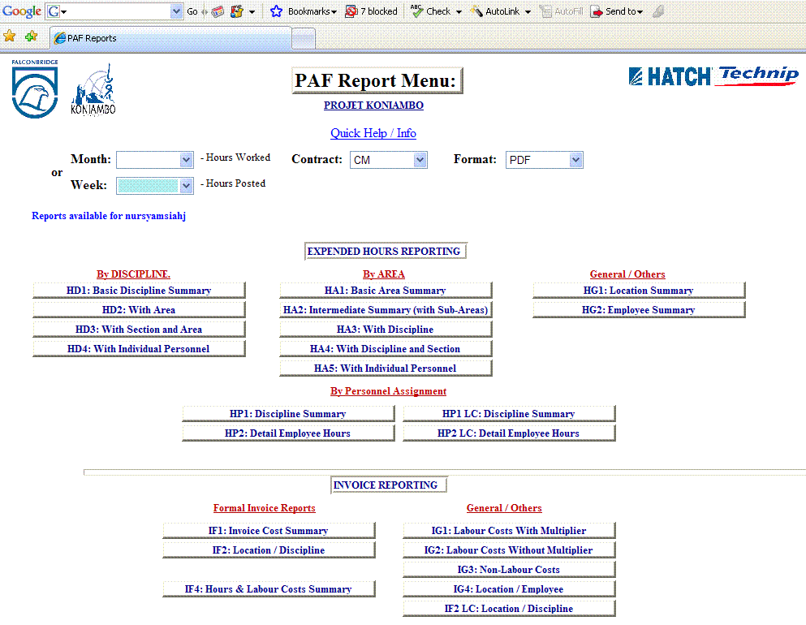
Figure 1: Previous PAF Report main menu

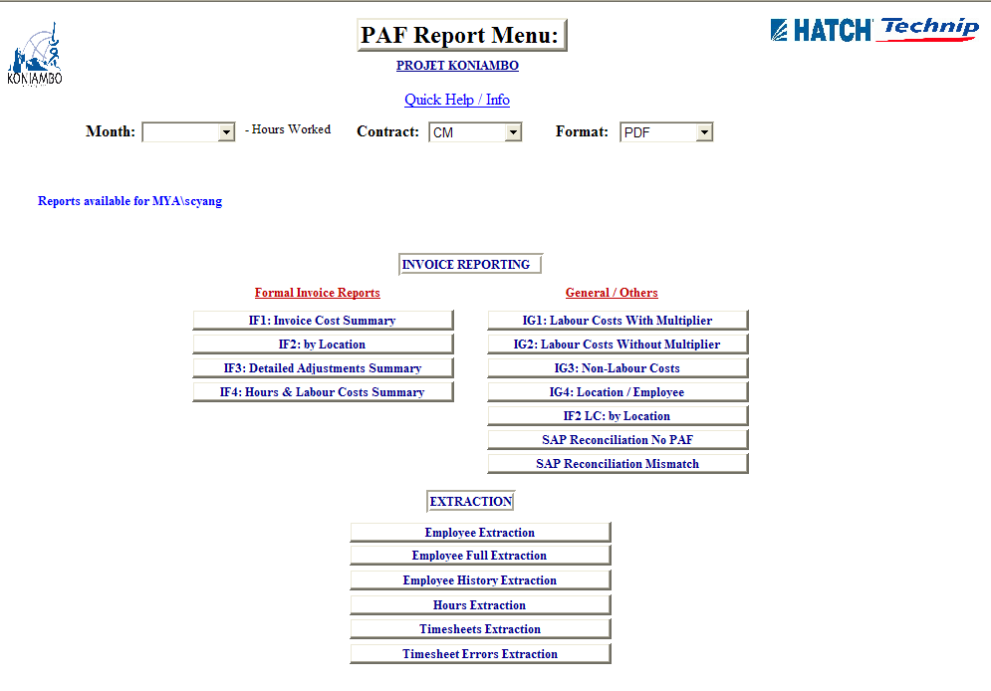
Firgure 2: Current PAF Report main menu.

Kindly refer to appendix for Invoice report.

Assumption and Constraint
- Employee which exists in SQL approved Timesheet will still remain in PAF Timesheet table until correction action taken.
- New PAF Employee which loaded into PAF_DATA must load or created by PAF Administrator for SOX Audit purposes.
- Email must enter into the PAF_DATA: Employee table, email field. Otherwise, the SQL weekly timesheet reminder will route to the PAF Administrator. False email must be rectified by PAF Administrator as soon as possible.
- PAF_DATA: Employee table might need to re-insert Position field since it might be used by Finance Cost Controller.
- Data in Hour table shouldn’t be removed since it has captured all the claimed timesheet on Oct to Dec (Done by Mr. Jean Caron as per request from Mr. Jaime Gatawa).
- Any new employee number, updating employee number and deleting employee number must inform IT.
- It is advised that the PAF Employee NO is defined well in the initial stage to avoid any inconsistency of data later.

Testing
The testing will cover
- PAF Adjustment
- PAF Database

PAF Adjustment

Test Cases: Access to PAF adjustment
Revision | 0 | Test Week | 2008/02/27
Remarks | - Launch PAF Adjustment.  - To check the role Access and PAF Adjustments function.
Bugs Reported
No Bugs found.
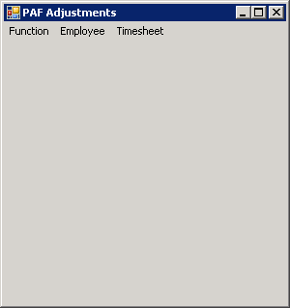

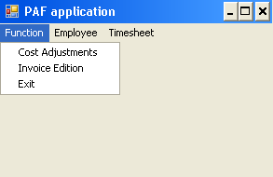

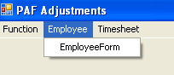

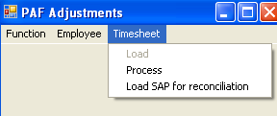

Test Cases: Employee

Revision | 0 | Test Week | 27 Feb – 27 Mar 08
Remarks | - PAF Adjustment->Employee->EmployeeForm  - Testing all Interface component.
Bugs Reported
Bugs found.
1. SQL Error Message
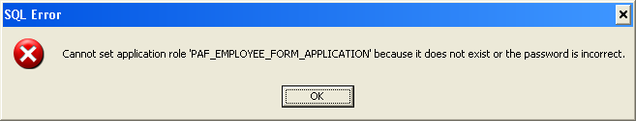

Caused:
The Application role didn’t set with the

Solution:
  - Goto Application Role, make sure the PAF_EMPLOYEE_FORM_APPLICATION is created.
  - Then make sure the Securables is set.
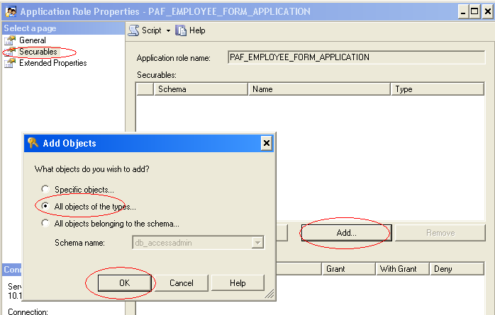
3. Make sure the table and Stored Procedure permission has granted.

- 2. Calendar cannot be updated even though we click on the “Save” button.
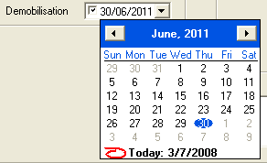

Caused:
Different regional setting on short date.

Solution:
Rectify the VB code to get the system short date format.

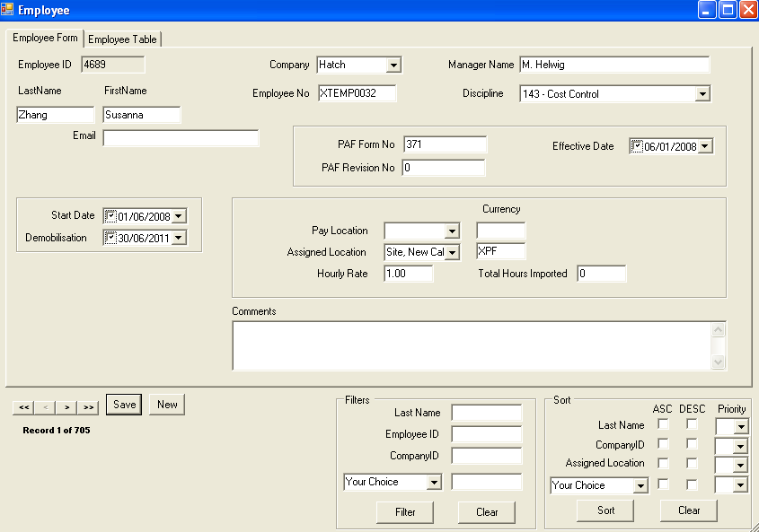

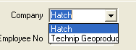

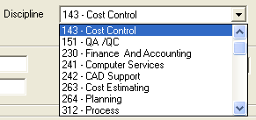

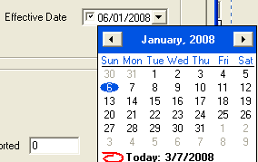

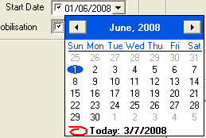

Test Cases: PAF Timesheet Process
Revision | 0 | Test Week | 2008/03/27
Remarks | - Launch PAF Adjustment.  - Go to Function->Timesheet->Process
Bugs Reported
No Bugs found.
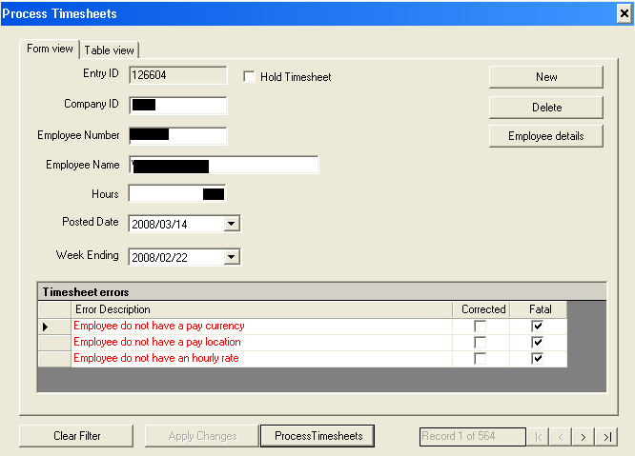

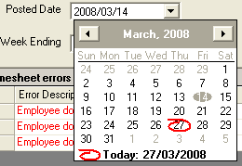

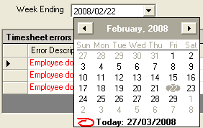

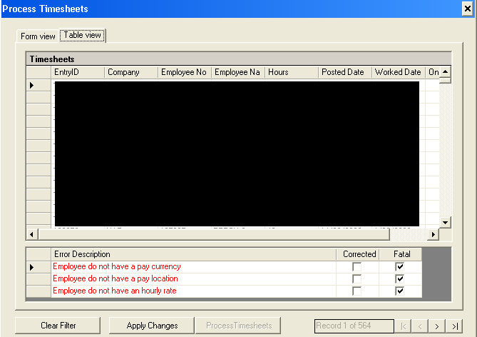

By clicking on the , it will open the Employee Form as shown below.

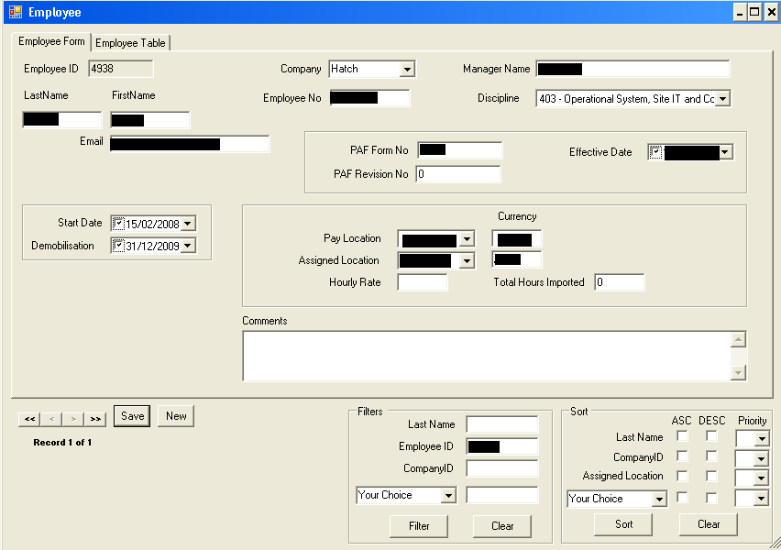

Test Cases: PAF Timesheet SAP Reconciliation
Revision | 0 | Test Week | 2008/03/27
Remarks | - Launch PAF Adjustment.  - Go to Function->Timesheet->SAP Reconciliation
Bugs Reported
No Bugs found.

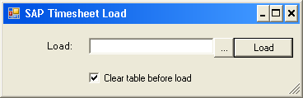

Checkbox “Clear Table before load” is checked if we wish to empty the SAPTimesheets table before loading the CSV file.
Done dialog is prompted once it is completed.

Test Cases: PAF Cost adjustment

Revision | 0 | Test Week | 2008/03/24
Remarks | - Launch PAF Adjustment.  - Go to Function->Cost Adjustment
Bugs Reported
1. Short Comments didn’t reinitialized while clicking “New” button. And problem while click on “Save” button.
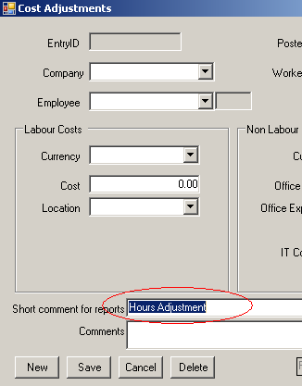
Caused: The problem is due to there is coding missing in data set created in the code.
Solution: Added the coding to bind the data set.

2. For certain Cost adjustment is not success even though we click the “SAVE” button.
Caused: The problem is due to the trigger (Hours->AdjustmentTriggers) that consists of condition to check the location value.
Solution: Removed the condition from the trigger.
[RatePayLocation] = (SELECT [RatePayLocation] FROM [dbo].[Employee] WHERE [EmployeeID] = @EmployeeID),

[RateAssignLocation] = (SELECT [RateAssignLocation] FROM [dbo].[Employee] WHERE [EmployeeID] = @EmployeeID),

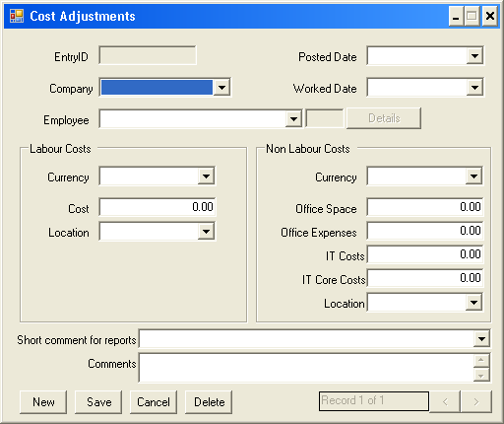

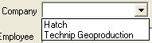

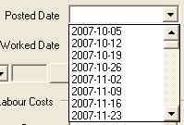

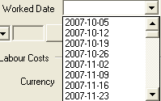

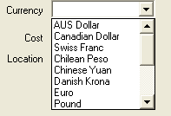

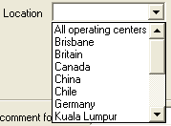

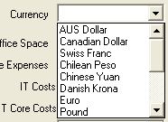

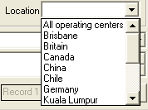

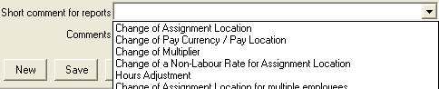

Test Cases: PAF Function Invoice Edition
Revision | 0 | Test Week | 2008/03/27
Remarks | - Launch PAF Adjustment.  - Go to Function->Invoice Edition
Bugs Reported
No Bugs found.
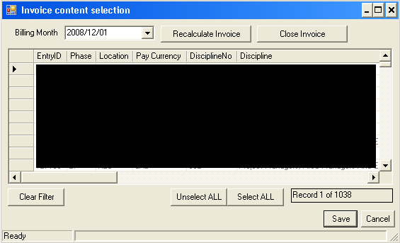

PAF Database

Test Cases: SQL Posting Timesheet to PAF

Revision | 0 | Test Week | 2008/03/24
Remarks | - Run HTJVDB store procedure (ExpPAFlog).  - Scheduling on every days 3.00 a.m..
Bugs Reported
- Cannot push.
Error: Cannot insert NULL in createddate.
Caused: Not allowed NULL value insertion.
Solution: Must set the createddate default value as getdate() in exppaflog table.

- All company is from TPG although the person is a HATCH staff.
Caused: The script is not updated. It will set all the company as “TPG” when it is not “HATCH” but current raw data is indicated Hatch staff as “HAT”.
Solution: Updated the script. Updated the data in exppaflog and timesheet.

